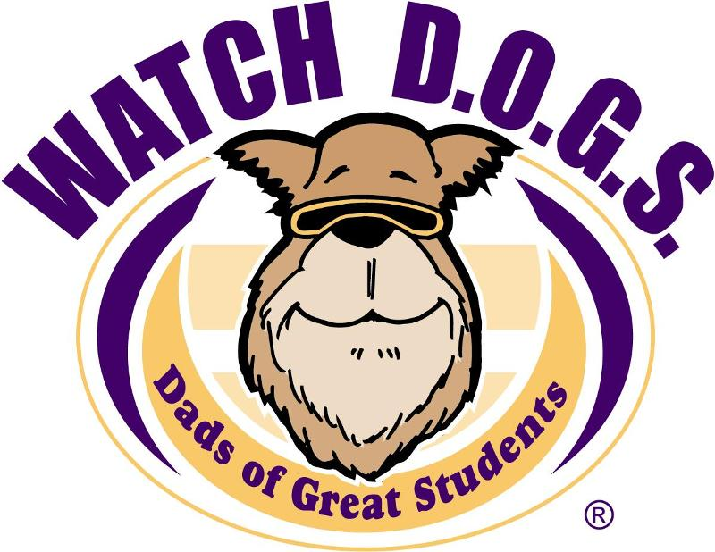

Calling all Watch D.O.G.S. volunteers and potential volunteers! Fathers, stepfathers, grandfathers, uncles,
and family friends are all welcome. Whether you are
able to volunteer one time, or many times throughout
the school year, it makes a difference!

If you are interested in joining the Watch D.O.G.S team, please go to https://goo.gl/forms/UpaXMSeytHpnLKv62 to complete the online registration form. More information on the Watch D.O.G.S. program will also be available at Pizza Night, on September 26, 2018 at 6:00 p.m.

Don’t forget that you must be DPS cleared to volunteer and it only takes a few moments online to do so. https://portal.neisd.net/vchrc/Default.aspx?SOURCE=V

SignUp (http://signup.com/go/VfTduvO):
We will be using SignUp to track and manage all Watch D.O.G.S. volunteer opportunities. This will allow us to accurately maintain a real time schedule of all volunteers and quickly react to last minute changes/updates. You will be able to check for available volunteer spots, make changes to existing commitments, and reschedule if necessary.

T-Shirts
We will be selling the required adult uniform shirt as well as the optional student shirts at Pizza Night on September 26th. If you cannot make it to pizza night, email the chair members at the address below and we will send an order form home with your student.

Email Communications:
All email communications should be directed to the watchdogs4huebner@gmail.com email account. Please do not email the chair members directly. If an urgent situation arises please reach out via phone or text to Madeline Biasiolli (210-391-5159).

Thank you all for your support of this program and for taking time to volunteer and make a difference in our children's lives. Your presence on campus is greatly appreciated not only by your student(s), but also by the PTA and faculty at Huebner Elementary.

Sincerely,

Huebner Watch D.O.G.S.

